实验8 序列相关性分析

蔡梦璋 2014211436

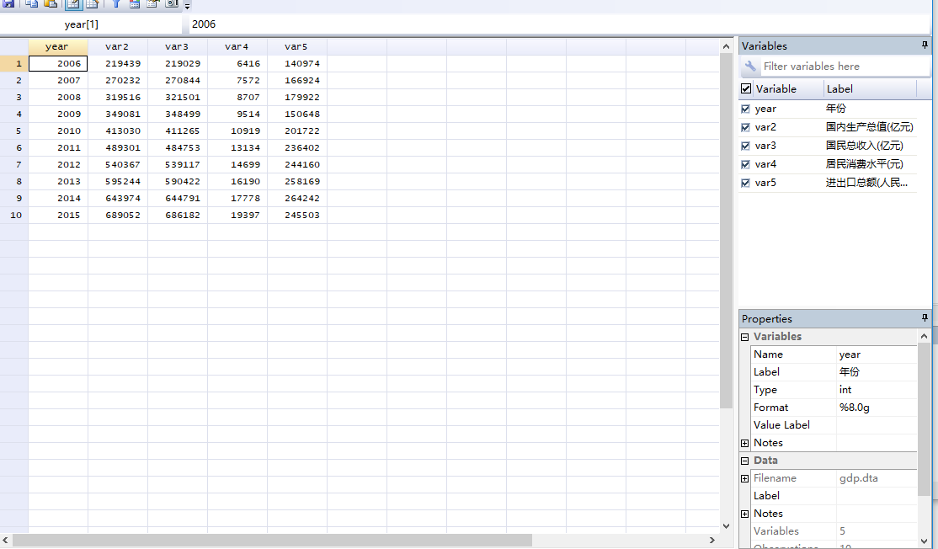

设置时间序列数据

. tsset year

time variable: year, 2006 to 2015

delta: 1 unit

. . reg var2 var3 var4 var5

Source | SS df MS Number of obs

> = 10

-------------+------------------------------ F( 3, 6)

> =14020.57

Model | 2.3951e+11 3 7.9837e+10 Prob > F

> = 0.0000

Residual | 34165721.8 6 5694286.97 R-squared

> = 0.9999

-------------+------------------------------ Adj R-squared

> = 0.9998

Total | 2.3955e+11 9 2.6616e+10 Root MSE

> = 2386.3

---------------------------------------------------------------------

> ---------

var2 | Coef. Std. Err. t P>|t| [95% Conf.

> Interval]

-------------+-------------------------------------------------------

> ---------

var3 | 1.01038 .1029511 9.81 0.000 .7584674

> 1.262292

var4 | -.3055736 3.399957 -0.09 0.931 -8.624968

> 8.013821

var5 | .0177843 .0571152 0.31 0.766 -.1219715

> .1575401

_cons | -3319.88 5428.095 -0.61 0.563 -16601.95

> 9962.19

---------------------------------------------------------------------

> ---------

采用图示检验法——残差图法

. predict e1,res

. gen e2=L.e1

(1 missing value generated)

. twoway (scatter e1 e2)

绘制e1与e2的散点图

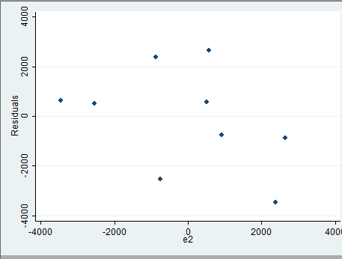

绘制时间序列图

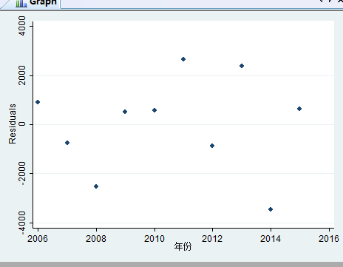

拉格朗日乘数检验

. wntestq e1

Portmanteau test for white noise

---------------------------------------

Portmanteau (Q) statistic = 6.1894

Prob > chi2(3) = 0.1028

采用DW检验

. estat dwatson

Durbin-Watson d-statistic( 4, 10) = 2.727516

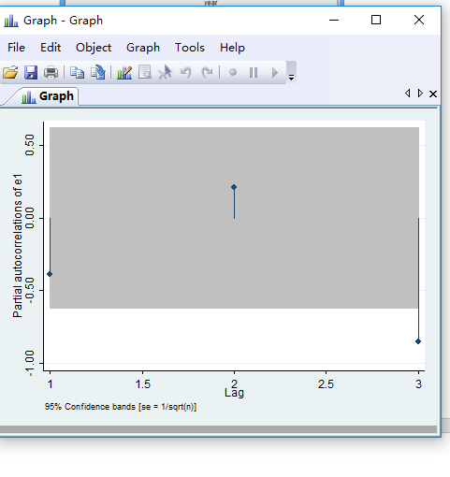

该时间序列为3阶相关时间序列

量化修正时间序列

. newey var2 var3 var4 var5,lag(2)

Regression with Newey-West standard errors Number of obs =

> 10

maximum lag: 2 F( 3, 6) =

> 35614.59

Prob > F =

> 0.0000

---------------------------------------------------------------------

> ---------

| Newey-West

var2 | Coef. Std. Err. t P>|t| [95% Conf.

> Interval]

-------------+-------------------------------------------------------

> ---------

var3 | 1.01038 .0363559 27.79 0.000 .9214202

> 1.099339

var4 | -.3055736 1.292057 -0.24 0.821 -3.467123

> 2.855976

var5 | .0177843 .0303566 0.59 0.579 -.0564956

> .0920642

_cons | -3319.88 2550.755 -1.30 0.241 -9561.351

> 2921.592

----------------